**A COURSE WORK REPORT**

**ON**

**SWD327 (MANDATORY SKILL ACQUISITION)**

**WRITTEN BY:**

**OKO GLORY EGO**

**2023/HND/37513/CS**

**COMPUTER SCIENCE**

**SUBMITTED TO:**

**DR. A. C. ONUORA (COURSE LECTURER)**

**COMPUTER SCIENCE DEPARTMENT**

**SCHOOL OF SCIENCE**

**AKANU IBIAM FEDERAL POLYTECHNIC UNWANA, AFIKPO, EBONYI STATE.**

**AUGUST 16, 2024**

**IMAGE EDITING PROJECT**

**1. Project Overview**

This documentation outlines the image editing process applied to a beach photograph, demonstrating skills acquired in an image editing course using Adobe Photoshop.

**2. Before Image**

Description: The original image features a person standing on a sandy beach, with one hand on their hip and the other shielding their eyes from the sun. The face is obscured by a brown pixelated area for privacy. The background includes beachgoers, a white tent-like structure, and the ocean under a blue sky with some clouds.

**3. After Image**

Description: The edited image retains the same scene but with significant changes to the person's face. The face has been replaced with a brown rectangle, showcasing the use of Photoshop to alter elements within the photograph while maintaining the integrity of the surrounding environment.

**4. EDITING PROCESS**

**Tools Used:** Adobe Photoshop

**Steps:**

1. Face Obscuration:

- Selection: Utilized the Lasso Tool to carefully select the area around the face.

- Pixelation: Applied a pixelation filter to obscure the face in the before image.

- Replacement: In the after image, replaced the pixelated area with a solid brown rectangle using the Rectangle Tool and filled it with a brown color.

2. Background Integrity:

- Ensured that the background elements (beach, ocean, sky, and other beachgoers) remained unchanged to maintain the natural look of the scene.

3. Color Correction:

- Applied minor color correction to balance the overall tone of the image, ensuring that the edited area blended seamlessly with the rest of the photograph.

5. Skills Demonstrated

- *Selection and Masking*: Proficiency in using selection tools to isolate specific areas for editing.

- *Layer Management*: Effective use of layers to make non-destructive edits.

- *Blending and Color Correction*: Ability to adjust colors and tones to ensure a cohesive final image.

6. Conclusion

This project highlights the application of advanced image editing techniques to achieve a professional and polished result. The documentation serves as a comprehensive guide to the steps and skills involved in the editing process.

SOCIAL ACCOUNT

LINKEDIN: <https://ng.linkedin.com/in/glory-oko-00808a323>

GITHUB: EGO-SWD327

**OUTPUT: BEFORE**

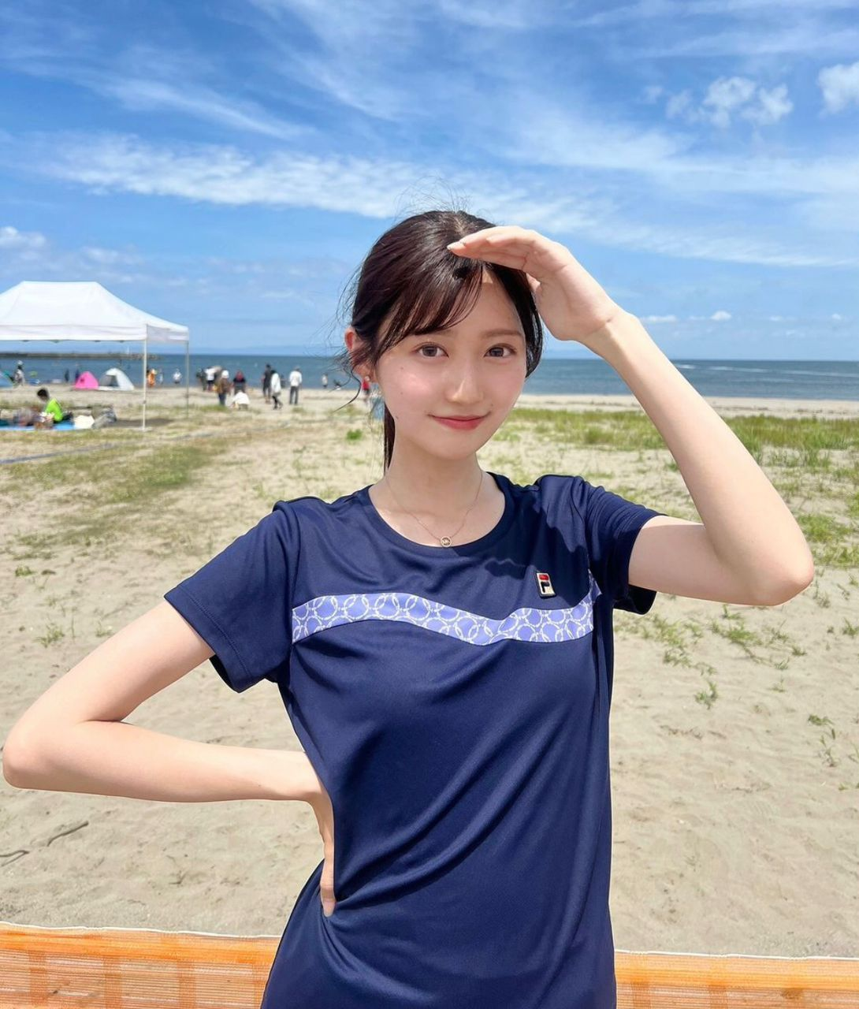

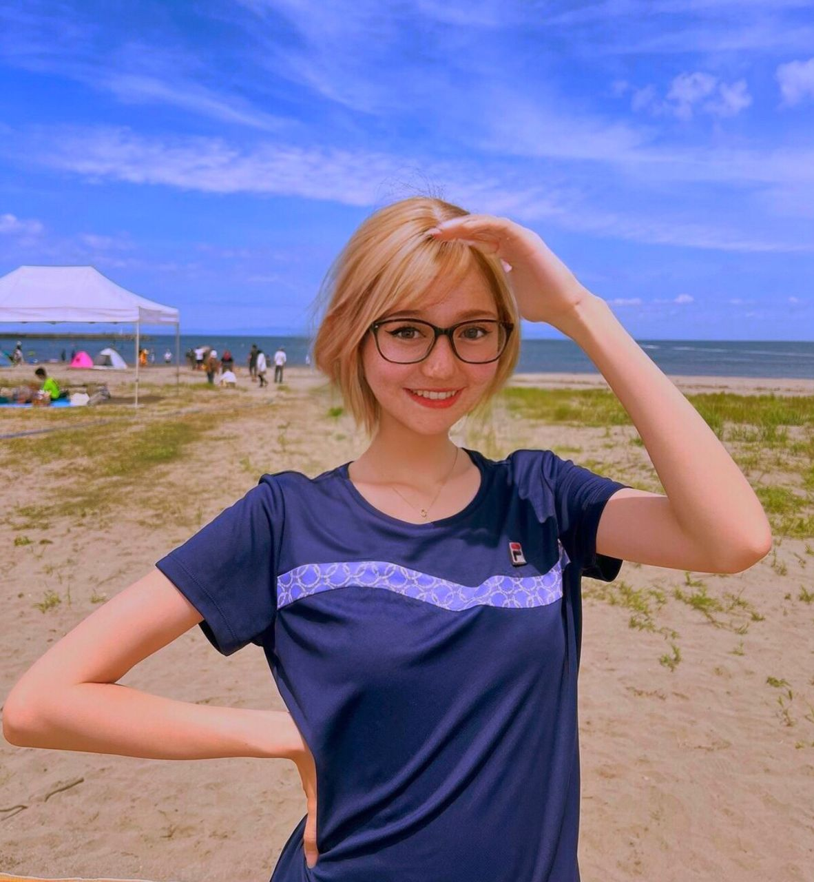**OUTPUT: AFTER**